Project 1: Visualizing Frequencies

Data does not always come in small chunks that are easy to understand and evaluate; data sets are often large and unwieldy. It is useful to be able to use software programs to evaluate and analyze data.

This is the first of 7 projects you will complete in this course using Excel. These projects are intended to help you get used to working with big data sets. In particular, this first project will help you learn to create different visual displays of data and compare them. You will also interpret different aspects of the data.

If you are new to Excel, you will want to learn some basics before you start. Microsoft has a lot of training videos available to help you. You can find them at <https://support.office.com/en-us/article/Excel-training-9bc05390-e94c-46af-a5b3-d7c22f6990bb?ui=en-US&rs=en-US&ad=US> . You should probably go there now and bookmark the support center. Throughout the semester, we’ll send you directly to some videos with links in the project directions.

Read the instructions here, then type your answers in the Response Template document. For full credit, you must use complete sentences and proper grammar in your responses!

# Instructions for Task 1:

During the first week of class we asked you to identify your favorite Oscar nominated movie from 2016. We have collected this data and included it in the data spreadsheet that you are working with.

Steps for Task 1:

1. In Excel open the spreadsheet Project 1 document, and open the tab labeled Oscar.
2. Use Excel to filter the data and create a frequency column in the table located in the Frequency Table for Oscar tab.
   * + To use the filter, first locate and click on the button that looks like a funnel similar to this:
       - If you are having trouble locating it, a quick Google search of “Microsoft Excel (version) Filter” should bring up how to locate it in your specific version.
     + In the bottom right hand corner of the Movie Preferences cell **A1** there is a small box with an arrow in it. Click on this to open a list of options.
     + At the bottom of this list of options, there are checkboxes with the names of the movies in it.
     + By clicking select all, you will uncheck all the boxes. You then can check the box for whatever movie for which you are trying to get the frequency.
     + Now that you have filtered the data, at the bottom of Excel (underneath the tabs for the different sheets, it will say “# of 297 records found.”
       - It should look similar to this: 
     + Repeat this process to get all the frequencies you need to fill out the table.
     + Here is a great video about filtering data: [Filtering Data](https://support.office.com/en-us/article/Video-Filter-data-by-using-an-AutoFilter-35e0a442-27e9-4400-8a78-35c26e1a51b0)
3. **Using Excel** create a relative frequency column in the provided table of the movie preferences of the class. **Note:** Excel allows for formulas to be entered into cells and will do the calculations for you! To do this follow these steps:
   * + In the Frequency Table for Oscars Spreadsheet locate cell **C2.**
     + In cell **C2** type the following without the quotation marks: “=**B2/$B$11”** and press Enter. In cell **C2** you should now see a long decimal that begins 0.063973…
     + Now copy and paste the formula to the rest of the cells for the relative frequency column.
     + Here is a link to the videos about formulas in Excel: [Using Formulas](https://support.office.com/en-us/article/Video-Create-formulas-23936c25-8fde-4ec3-a868-a8add99f884d?ui=en-US&rs=en-US&ad=US)
4. Using Excel, create a frequency bar graph (called a column chart in Excel) for the movie preferences of the class.
   * Highlight the data located in columns **A** and **B** that you would use to create a frequency bar graph.
   * In the top tool bar of Excel there will be an area labeled Charts. You may need to click the “Insert” tab. This screenshot gives an idea of what to look for:

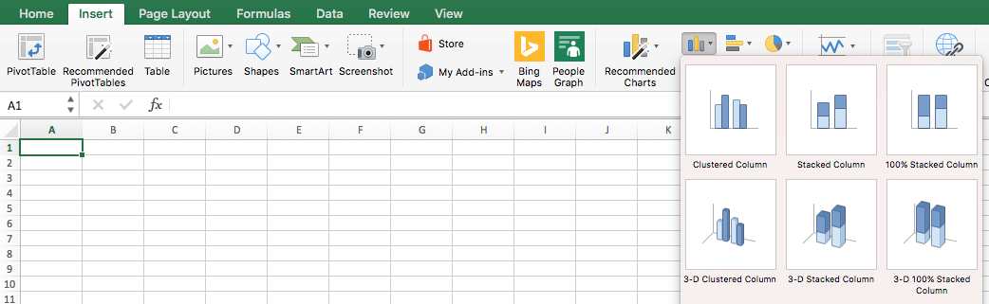

* + Select Clustered Column.
  + Make sure to appropriately label the axes and give the chart a title.
* To add titles, click on the chart and then click on chart format in the top tool bar or on the right hand side.
* **Note:** You can Copy and Paste charts directly from Excel into Microsoft word. Do this instead of taking screen shots!
* You may want to refer to the video about [Creating Charts](https://support.office.com/en-us/article/Video-Create-charts-231c42d2-5e58-40e1-99f0-cbe618cfee1d?ui=en-US&rs=en-US&ad=US).

1. Using Excel, create a pie chart of the class’s favorite movie preference. (A pie chart is a relative frequency distribution of a categorical variable.)

* Make sure to appropriately label the categories and give the chart a title.

# Instructions for Task 2:

During the first week of class, we asked you to identify your favorite YouTube video from the most popular videos from the previous year. This Task works with that data.

Steps for Task 2:

1. In Excel open the Project 1 spreadsheet document, and utilize the tabs labeled YouTube and Two Way Table for YouTube.
2. Using Excel create a two-way table comparing favorite YouTube video and gender.

* Note: You can filter multiple columns. For example, you can filter the gender column and then favorite YouTube video.
* For information on filtering see the instructions for Task 1.

1. Select cells A2 through D12 in the “Two Way Table for YouTube” sheet and create a multi-bar graph (Excel calls this a Clustered Column graph) for the favorite YouTube videos of the class.

* The graph should show information about favorite movies, broken down by male/female/prefer not to say.
* For full credit, you must appropriately label the axes and give the chart a title.
* If you need more help, the video [Creating Charts](https://support.office.com/en-us/article/Video-Create-charts-231c42d2-5e58-40e1-99f0-cbe618cfee1d?ui=en-US&rs=en-US&ad=US) should give you the assistance you need.